**A Killer Hangover**

**User manual**

**Introduction**

The University of York has been invaded by zombies!

Your task is to kill as many zombies as you can and defeat the two main bosses leading the attack to prevent the total annihilation of lectures.

**Game Characters**

In the game, you have the option to play as Player 1 or Player 2.

Choose wisely; one of the players has higher speed, but less health.



## 

## 

Your aim is to shoot the zombies, which will be displayed as shown:



## 

One zombie is faster than the other, so beware!

**Game layout**

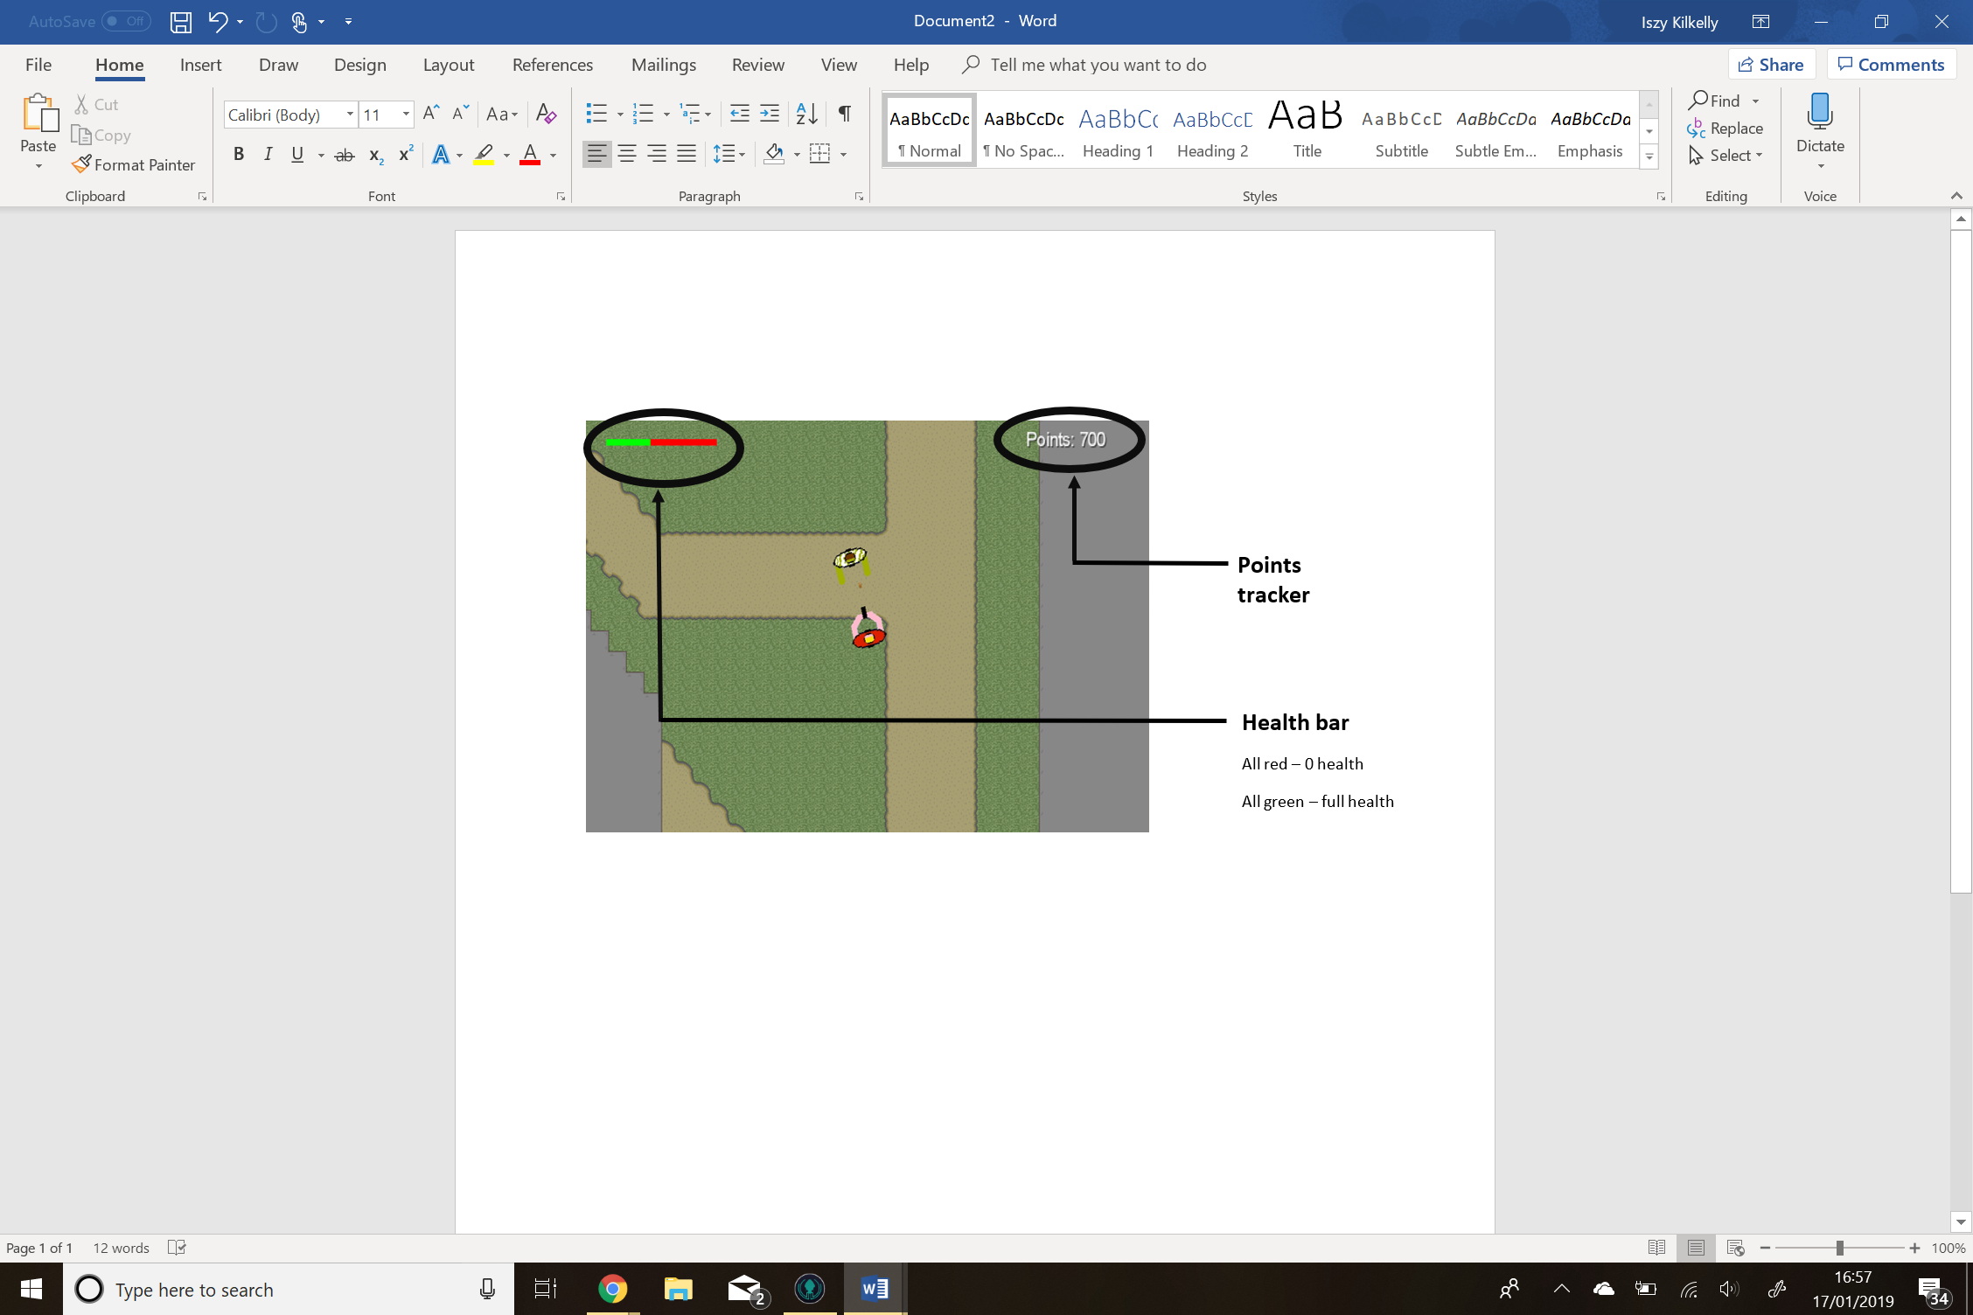

**Movement**

To move your characters around the scene, the following controls are used:

* UP - ‘W’ key
* DOWN - ‘S’ key
* LEFT - ‘A’ key
* RIGHT - ‘D’ key

To change the direction to which your player is facing, you use the mouse/trackpad. The player will point towards the cursor and can turn 360 degrees.

**Shooting**

To attack a zombie, point your cursor in the direction of the zombie and left-click on your mouse/trackpad.

**Main menu**

When you first start, the game the main menu will appear. You will be asked to choose between playing as Player 1 or Player 2. You can do so by left-clicking on your selected option.

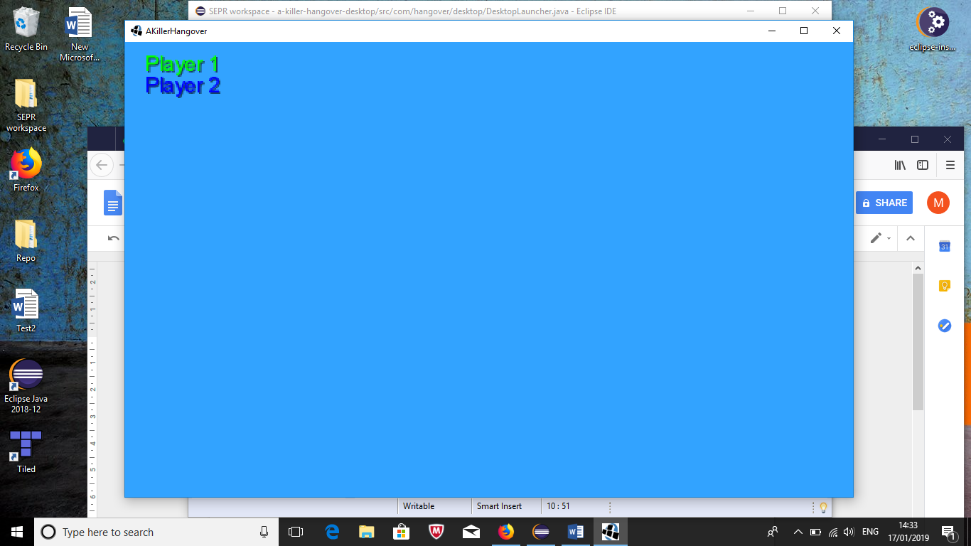

**Map menu**

When you first play the game you will be automatically placed in the first zone: ‘The Flat’. Once you leave this zone a map menu will appear giving you several different zones to visit next.

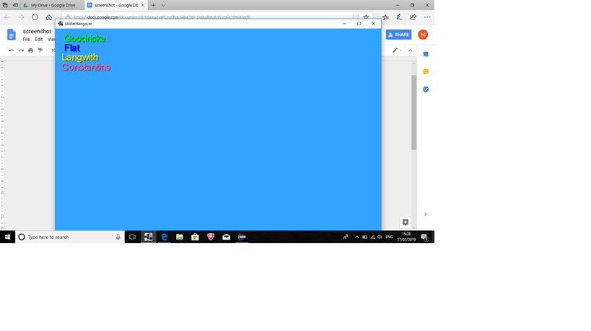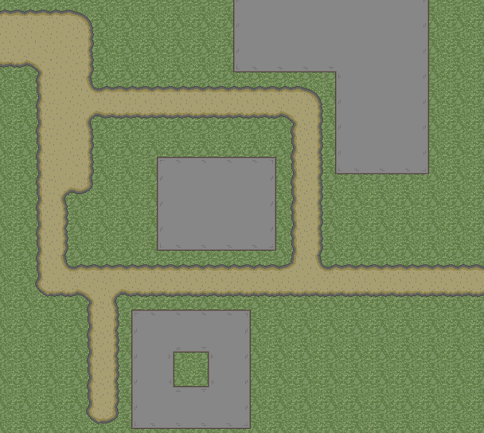



You can select which zone you want to enter by left-clicking on your chosen zone.

**Safe Zones**

Certain zones in the game are referred to as ‘Safe Zones’. Once you enter these zones, two things will happen:

* The player will gain 1000 points
* Zombies will spawn more quickly

nb. these features have yet to be implemented so that they work...

**“Powerups”**

There are 3 “powerups” in the game. One speeds you up, one slows you down and one heals you. I’m not gonna tell you which does what. It’s not my job.

**Enjoy the game!**

